Transport Layer:
- Transport layer provides end to end transport of message between remote applications
- Transport layer provides logical communication between processes running on different hosts, however, a network layer protocol provides a logical communication between the hosts
- The internet makes two distinct transport-layer protocols available to the application layer:
  - UDP (User Datagram Protocol): connectionless / unreliable service to the invoking applications
  - TCP ( Transport Control Protocol): provides a connection-oriented service to the invoking applications
- A transport layer packet is referred to as a segment
- The IP service model makes the “best effort” to deliver segments between communicating hosts known as the best effort delivery service, however it does not guarantee segment delivery. For this reason, IP is said to be an unreliable service
- The most fundemental responsibility of TCP/UDP is to extend the IP’s delivery service between two end systems to the delivery of service between two processes running on those end systems
- Extending host-to-host delivery to process-to-process delivery is called transport-layer multiplexing and demultiplexing
- Both TCP/UDP provide integrity checking by including error-detection fields in their segments headers.
- The minimal two aforementioned services (process-to-prcess data delivery and error checking) are the only two services that UDP provides
- Like IP protocol, UDP is unreliable
- UDP does not:
  - Retransmit corrupt packets
  - Do congestion control
  - Do flow control

- TCP on the other hand, offers several additional services to applications:
  - Reliable data transfer (it ensures that the packets are delivered to the receiving processes, correctly and in order using some techniques: flow control, sequence numbers, acknowledgments, and timers)
  - Congestion Control (recall that the internet is made above TCP/IP, where IP serves the fast forwarding of packets and TCP ensures congestion control). TCP ensures congestion control by giving each connection traversing a congested like an equal share of link bandwidth, which is done by regulating the rate at which the sending sides of TCP connections can send traffic into the network. UDP traffic from the other side, is unregulated, thus hosts can send data at any rate
Multiplexing and Demultiplexing:
- Demultiplexing refers to the process of delivering the data in a transport-layer segment to the correct socket
- Multiplexing refers to the job of gathering data chunks at the source host from different sockets, encapsulating each data chunk with header information to creating segments and passing those segments to the network layer
- TCP/UDP segments have special fields ensuring multiplexing and demultiplexing are done properly (those are source port number field and the destination port number field)
- A port number is a 16-bit number ranging from 0 to 65535
- The port numbers from 0 to 1023 are well-known port numbers and they are restricted for use by well-known protocols such as HTTP (on port 80)
Connectionless Transport: UDP:
- UDP does just about as little as a transport protocol can do
- If the application developer chooses UDP instead of TCP, then the application is almost directly talking with IP
- UDP takes messages from the application process, attaches the src and dst port number fields (for multiplexing/demultiplexing function), adds two other small fields, and then passes the resulting segment to the network layer
- The network layer encapsulates the transport layer-segment into an IP datagram and then makes the best effort attempt to deliver the segment to the receiving host
- If the segment arrives at the receiving host, UDP uses the destination port number to deliver the segment’s data to the correct application process
- With UDP, there is no handshaking between sending and receiving transport-layer entities before sending a segment, hence UDP is connectionless
- DNS and DHCP are examples of application-layer protocols that use UDP segments

A sneak peak of How DNS query is passed to the destination host:
- When a DNS application in a host wants to make a query, it constructs a DNS query message and passes the message to UDP
- Without performing any handshaking with the UDP entity running on the destination end system, the host-side UDP adds header fields to the message
- The resulting segment is then passed to the network layer-segment
- The network layer then encapsulates the segment into an IP datagram and sends the datagram a name server
- The DNS application at the querying host then waits for a reply to its query
- If it doesn’t receive a reply, it might try resending the query, try sending the query to another name server, or inform the invoking application that it can’t get a reply

Why an Application developer would ever choose to build an application over UDP rather than TCP:
- Speed, especially for real-time applications, because TCP doesn’t tolerate data loss. These applications can use UDP and implement, as part of the application, any additional functionality that is needed beyond UDP’s no-frills segment-delivery service (no-frills refers to a business or service which focuses on providing only the essential features, i.e basic offering ONLY)
- No connection establishement: does not introduce any delay to establish a connection. This is the principle reason why DNS relies on UDP rather than TCP. HTTP uses TCP rather than UDP, since reliability is critical for web pages with text (The delay of issuing a TCP connection is critical for downloading the content of the HTTP page)
- No connection State: TCP maintains connection state in the end systems. This connection state includes receive and send buffers, congestion control parameters, and sequence and acknowledgment number parameters. We will see that the aforementioned points are essential to implement TCP’s reliable data transfer service and provide congestion control. UDP however, does not keep track of any of those parameters. For this reason, a server devoted to a particular application can typically support many more active clients when the application runs over UDP than TCP
- Small packet header overhead: TCP segement has 20 Bytes of header overhead in every segment, whereas UDP has only 8 Bytes of overhead

Note:
- Early versions of HTTP ran over TCP but that more recent versions of HTTP run over UDP, providing their own error control and congestion control (among other services) at the application layer
- Many important applications run over UDP rather than TCP, for example Network management (SNMP) since network management applications must often run when the network is in a stressed state
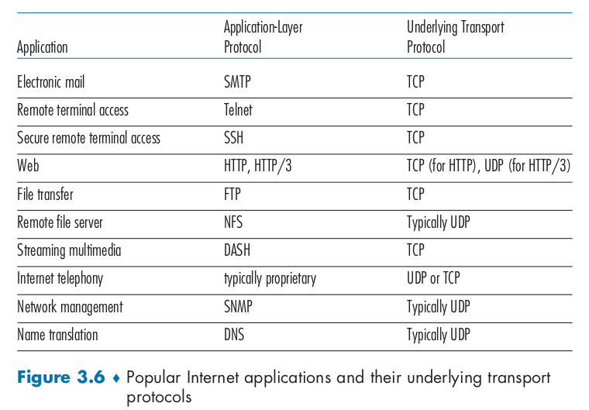
- Although commonly done today, running multimedia applications over UDP needs to be done with care. As we mentioned above, UDP has no congestion control.
- If everyone were to start streaming high-bit-rate video without using any congestion control, there would be so much packet overflow at routers that very few UDP packets would successfully traverse the source-to-destination path. Moreover, the high loss rates induced by the uncontrolled UDP senders would casue TCP senders to dramatically decrease their sending rates (TCP does so in the face of congestion) resulting in the crowding out of TCP sessions
- Again, we can ensure reliability even when using UDP segments, by implementing it in the application level

UDP segement Structure:
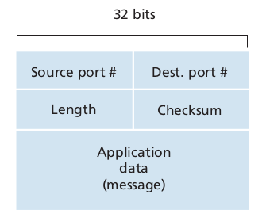
- Data: contains the actual data (for example the query message or response message in DNS)
- Port numbers: allow for multiplexing/demultiplexing
- Length field = The number of Bytes in the UDP Segment (length_size = header_size + data_size), why? It is needed because the data field may differ from one UDP segment to the next

- Checksum: to check whether accidental errors have been occurred (concurrently, to check whether bits within the UDP segment have been altered). How to calculate the checksum?
  - Sender Side:
1. Sum all the three 16-bit fields (bitwise addition)
2. Return the 1’s complement of the result of the sum, if any overflow is present, wrap it around
  - Receiver Side:
1. Sum all the four 16-bit fields (including the checksum field)

Why are we concerned with calculating the checksum at the transport layer as many link layer protorols (including the popular ethernet layer) do so?
The reason behind that is that there is not guarantee that the links between the source and the destination provide error checking (it is likely that one of the link between the src and the destination does . The second reason, is that even if segments are correctly transferred, it is possible that bit errors could be introduced when the segment is stored in router’s memory
Note:
- Although UDP provides error checking, it doesn’t do anything to recover from an error. Some implementations simply discard the damaged segment, others pass the damaged segment to the application with a warning
- The header size of a UDP segment is 8 Bytes

Real Transport Protocol:
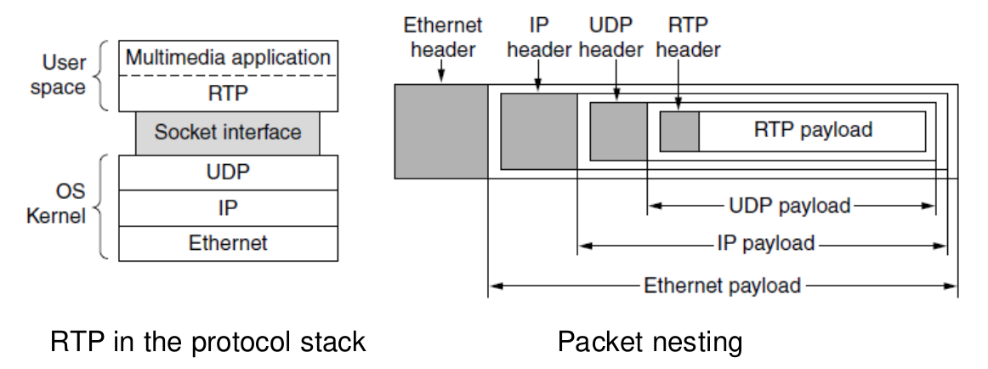
- Real Transport Protocol is a transport protocol that is implemented in the application layer, it is used for delivering audio, video, and other real time data over the internet, commonly used in VoiceOver IP VoIP, streaming media…
- RTP typically runs over UDP because it prioritizes speed over reliability

- RTP segments include sequence numbers (to reorder the packets in case they arrive out of order) and timestamps (to synchronize media streams) and a payload type
- RTP is essential for real time media streaming

Difference between RTP and UDP:
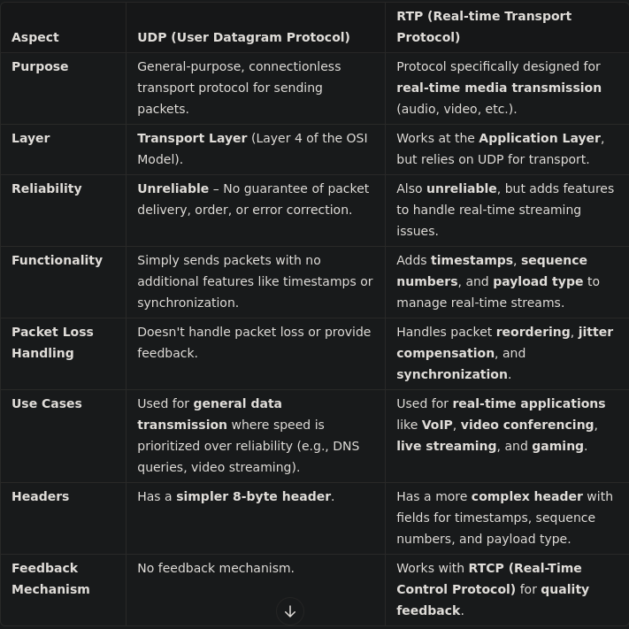
- RTP packets may be lost or delayed and there is no guarantee about delivery
- If a packet is missing, the application runs interpolation(a technique used to estimate the missing values based on surrounding packets) to compensate for the loss, retransmission is not helpful as it may arrive late

- RTP allows you to create profiles for different types of media streams. A profile specifies what kind of media is being sent and how it should be handled, for instance, a single audio stream profile might be used for VoIP call
- Specifies encoding scheme. RTP doesn’t just send raw media data, it needs to know how the media is encoded (compressed) for each profile. For each profile, it specifies the encoding scheme to be used, H.264, and H.265 are popular video compression standards
- Uses time-stamping (difference between timestamps) to allow applications to buffer packets to avoid delay variation effects. Each RTP packet has a timestamp that shows when the packet was created. This allows the receiving application to reorder the packets and buffer them to handle jitter (the variation in packet arrival time). Buffering is useful to handle jitter because the application stores a few packets temporarily (buffer them) before playing them to smooth out any irregularities in packet arrival time
Note: Time-stamping also helps synchronising different media (e.g. a TV program may have one video stream and two audio streams). The timestamps ensure that the video and audio stay in sync, even if packets for one stream arrive faster than the other
RTP Packet Header:
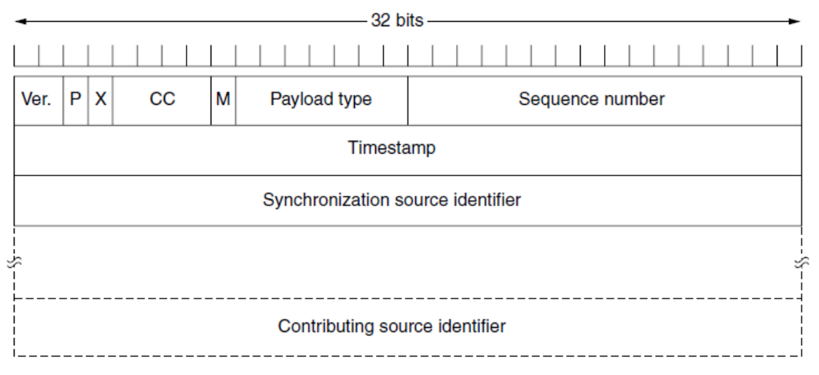
Here are some details about each of the packet fields:
- Ver. RTP version (the current version is 2)
- P means that the packet is padded (extra bit at the end of the packet)
- X means an extra extension byte header is added (the added header is between data and the basic header)
- contribCC: contributor count tells how many contributing sources are used. There is a maximum of 15 contributors
- M: used by the application as an end marker to indicate the end of its data
- Payload type: to indicate the type of the payload (type of the media)
- Sequence Number: to give a serial number to RTP packets. It helps in sequencing. The sequence number of the first packet is given by a random number, and then every next packet’s sequence number is incremented by 1
- Timestamp: to find relationship between times of different RTP packets. The timestamp for first packet is given randomly and then time stamp for next packets given by sum of previous timestamp and time taken to produce first byte of current packet.
- RTCP provides a feedback on the quality of the RTP stream (jitter, packet loss)
- Synchronization Source Identifier:a 32-bit field to identify and define the source. The value of this identifier is a random number chosen by the source itself
- Contributor Identifier: This is also a 32-bit field used for source identification where there is more than one source present in session. The mixer source use Synchronization source identifier and other remaining sources (maximum 15) use Contributor identifier.

Real Transport Control Protocol:
- RTCP is a sister protocol of RTP
- RTCP is used to monitor and control the RTP session to ensure smooth and synchronized playback
- The primary function of RTCP is to provide feedback on the quality of service (QoS) in media distribution by periodically sending statistics information to participants in a streaming multimedia session.
- The feedback loop allows the media session to adjust dynamically based on network conditions such as:
  - Delays
  - Packet Loss
  - Jitter (the variation in packet arrival time)
  - Bandwidth usage
- Note: Congestion can be measured by packet loss or delay
- RTCP reports help both ends of the communication to adjust their data transmission rates to maintain a smooth call/video stream...
- If a packet loss is high, the system can reduce the bitrate or switch to a more robust codec to ensure continuity, for example switch from HD video to SD video in poor network conditions
- If the network is functioning well, the system can increase the quality of the stream by using a higher bitrate

Buffering and Jitter Control:
- Even if packets are sent out regularly from the source, network congestion, routing variations, or other factors can cause them to arrive at the receiver with irregular timing causing high Jitter rate
- The impacts of jitter are given below:
  - Jerky Video: In video streaming, jitter leads to uneven frame rates, resulting in jerky playback.
  - Unintelligible Audio: In audio streaming, jitter can cause gaps or distortions in the audio.
- One solution to address this problem is to use Buffering
- Buffering involves storing incoming packets in a temporary storage area (buffer) before they are played back.

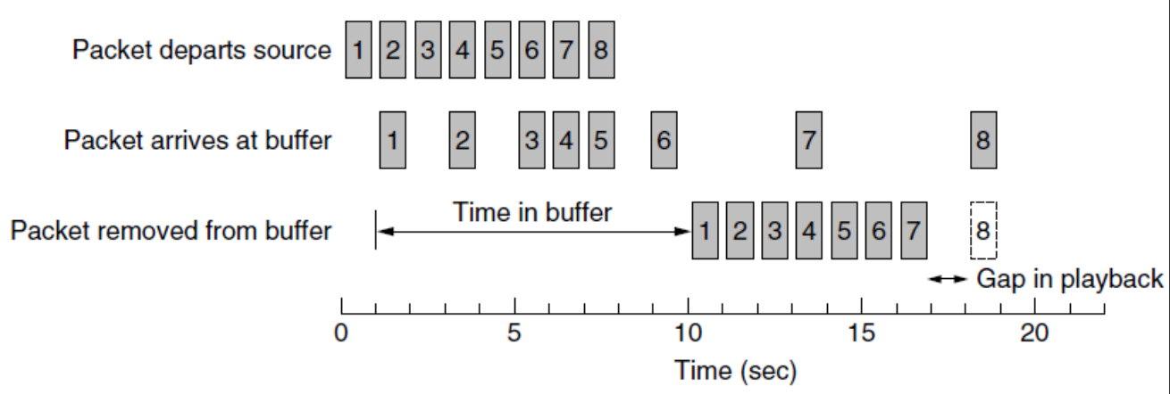
- Packet 8 still arrives late. Either discard (voice-over-IP) or pause the video and wait (video streaming)
- For video streaming using a 10s buffer can be reasonable to absorb network delays of packet that are not dropped.
- For interactive applications (e.g. video-conferencing), a smaller buffer is needed for responsiveness.

What is a playback point?
- Suppose you are watching a movie that is being streamed over the internet. Think of a playback Point as a tiny pointer moving along the timeline of the movie. This pointer represents the playback point. It indicates the exact moment in the movie that is being played back on your screen.

A window:
The range of permissible sequence numbers for transmitted but not yet acknowledged packets can be viewed as a window of size N over the range of sequence numbers. As the protocol operates, this window slides forward over the sequence number space. Why not allow an unlimited number of such packets? The flow control is one reason to impose a limit.
on the sender. If the window is full, the sender simply returns the data back to the upper layer, an implicit indication that the window is full. (in GBN)

Transmission Control Protocol (TCP):
- TCP is the internet’s transport layer connectio-oriented, reliable transport protocol
- TCP relies on many principles to ensure a reliable communication including error detection, retransmissions, cumulative acknowledgments, timers, and header fields
- TCP is said to be connection-oriented because before one application process can begin to send data to another, the two processes must first “handshake” with each other—that is, they must send some preliminary segments to each other to establish the parameters of the ensuing data transfer
- The TCP connection is a logical one, with common state residing only in the TCPs in the two communicating end systems (The state of the connection is maintained only at the two endpoints by the TCP protocol running in the respective devices. This state includes information such as variables, sequence numbers, acknowledgment numbers, and buffers)
- Intermediate network devices (routers and link-layer switches) don’t have the connection state, they simply forward packets based on the IP headers, without knowing or caring about the TCP state
- A TCP connection provides a full duplex service, that said If there is a TCP connection between Process A on one host and Process B on another host, then application-layer data can flow from Process A to Process B at the same time as application-layer data flows from Process B to Process A
- A TCP connection is point to point, that said multicasting (the transfer of data from one sender to many receivers in a single send operation) is not possible, unlike UDP based protocols

A three-way handshake:
- Let’s suppose that a process running on a host A wants to initiate the connection with a process running on host B, we call the process that initiates the connection the client process and the process to which the connection is made the server process
- The client application process first informs the client transport layer that it wants to establish a connection to a process in the server
- TCP in the client then proceeds to establish a TCP connection with TCP in the server
- The client first sends a special TCP segment “I want to communicate”
- The server sends a special TCP segment too “I want to communicate too”
- finally the client responds again with a third special segment
- The first two segments carry no payload, that is, no application-layer data; the third of these segments may carry a payload
- Once a TCP connection is established, the two application processes can send data to each other

Sending Data from the Client Process to The Server Process:
- Let’s consider the sending of data from the client process to the server process
- The client process passes a stream of data through the socket (the door of the process), once the data passes to the door, the data in the hands of TCP running in the client
- TCP directs this data to the connection’s send buffer, which is one of the buffers that is set aside during the initial three-way handshake
- From time to time, TCP will grab chunks of data from the send buffer and pass the data to the network layer
- WHAT IS THE MAXIMUM AMOUNT OF DATA THAT CAN BE SENT AT A TIME?
- The maximum amount of data that can be grabbed and placed in a segment is limited by the maximum segment size (MSS)
- MSS is the maximum amount of data a transport-layer segment can hold in its payload
- MTU is the maximum amount of data a link-layer (an Ethernet) frame can hold OR the largest IP packet size (including its header)
- The MSS is typically set by first determining the MTU and subtracting from it the IP header size and the TCP header size, we obtain the following:

MSS = MTU – 20 (IP header size) – 20 (TCP header size) = 1500 – 20 – 20 = 1460
MSS = 1460
- TCP pairs each chunk of client data with a TCP header, thereby forming TCP segments. The segments are passed down to the network layer, where they are separately encapsulated within network-layer IP datagrams. The IP datagrams are then passed to the link layer, where they are encapsulated within an ethernet frame.
- When TCP receives a segment at the other end, the segment’s data is placed in the TCP connection’s receive buffer, as shown below. The application reads the stream of data from this buffer.
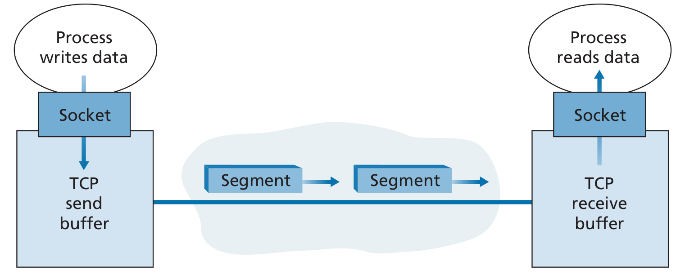

- Each end of the connection has its own send buffer and receive buffer

TCP Segment Structure:
- The TCP segment consists of header fields and a data field.
- The data field contains a chunk of application data. As mentioned above, the MSS limits the maximum size of a segment’s data field to 1460 Bytes. When TCP sends a large file, such as an image as part of a Web page, it typically breaks the file into chunks of size MSS (except for the last chunk, which will often be less than the MSS).
- Interactive applications, however, often transmit data chunks that are smaller than the MSS; for example, with remote login applications such as Telnet and ssh, the data field in the TCP segment is often only one byte. Because the TCP header is typically 20 bytes (12 bytes more than the
- UDP header), segments sent by Telnet and ssh may be only 21 bytes in length.
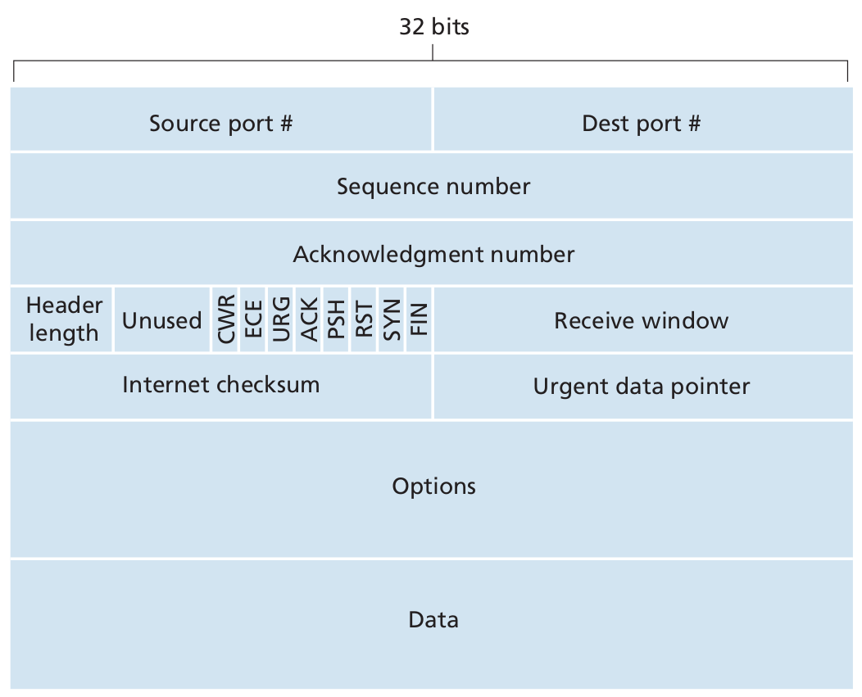

- Source port # and Destination port # are used for multiplexing/demultiplexing from/to upper-layer applications.
- Checksum field is included for integrity

The unit below is in Bytes:
- The 32-bit sequence number field
- 32-bit acknowledgment number field
- The 16-bit receive window: used for flow control, it is used to indicate the number of bytes that a receiver is willing to accept (or the sender is allowed to transmit) before waiting for an acknowledgment from the receiver. It is represented as the free space in the receiver’s buffer space in Bytes
Note: The window size is part of TCP's sliding window mechanism, which ensures that data is sent at a rate that the receiver can handle.
- Options field: is an optional and variable-length field used when a sender and receiver negotiate the maximum segment size (MSS) or as a window scaling factor for use in high-speed networks
- Flag field: contains 6 bits:
  - ACK → used to indicate that the value in the acknowledgment field is valid, that is, the segment contains an acknowledgment for a segment that has been successfully received
  - The RST, SYN, and FIN bits are used for connection setup and teardown:
    - RST → To reset the connection (e.g, when a problem arises)
    - SYN → used to establish a connection
    - FIN → used to release the connection
  - TCP header length is needed because the options field is has variable length
  - CWR and ECE bits are used in explicit congestion notification
  - PSH → PSH bit indicates that the receiver should pass the data to the upper layer immediately
  - URG → is used to indicate that there is data in this segment that the sending-side upper-layer entity has marked as “urgent”. The location of the last byte of this urgent data is indicated by the 16-bit urgent data pointer field

Sequence Numbers And Acknowledgment Numbers:

Sequence Numbers:
- The TCP implicitly numbers each byte in the data stream, consisting what is known as a sequence number
- Sequence numbers are over the stream of transmitted bytes and NOT over the series of transmitted segments
- The sequence number for a segment is therefore the byte-stream number of the first byte in the segment
Note: In reality, both ends in a TCP connection choose a random initial sequence number to start from, but it is often encountered as 0

Acknowledgment Numbers:
- Recall that TCP is full-duplex, so that Host A may be receiving data from Host B while it sends data to Host B (as part of the same TCP connection)
- Each of the segments that arrive from Host B has a sequence number for the data flowing from B to A
- The acknowledgment number that Host A puts in its segment is the sequence number of the next byte Host A is expecting from Host B
- The acknowledgment number is what the host transport layer puts in the acknowledgment field of the TCP header

Note:
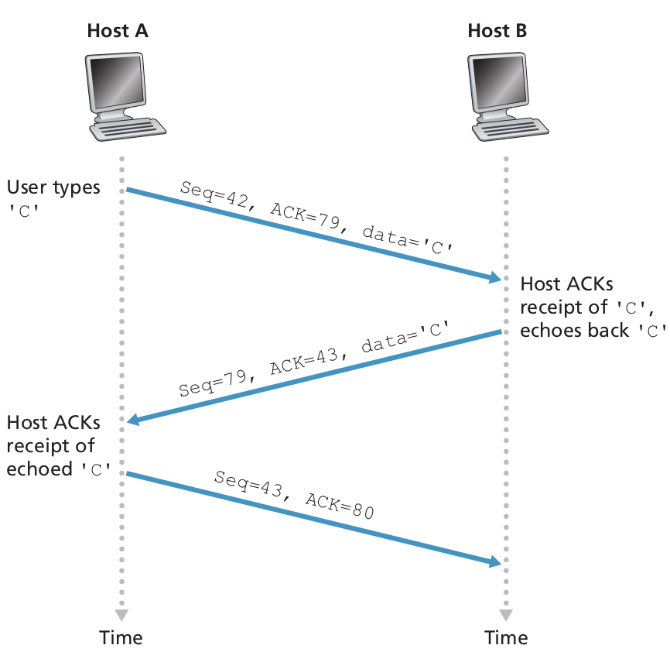
  - Note that the acknowledgment for client-to-server data is carried in a segment carrying server-to-client data; this acknowledgment is said to be piggybacked on the
server-to-client data segment.
  - The third segment sent from the client to the server has an empty data field
  - Host B does not always send an empty segment for every data segment it receives. It may send an ACK-only segment if there is no data to send. For example, this happens during one-sided communication (like a file download).

What does a host do when it receives out-of-order segments in a TCP connection?
- TCP RFCs do not impose any rules here and leave the decision up to the programmers implementing a TCP implementation
- There are basically two choices:
  - The receiver immediately discards out-of-order segments (which, as we discussed earlier, can simplify receiver design)
  - the receiver keeps the out-of-order bytes and waits for the missing bytes to fill in the gaps. Clearly, this approach is the most reliable and is the approach taken in practice

What is the sequence number?
Is a field of a data packet, resulting from the sender numbering its data packets by putting a sequence number into this field

